**CHAPTER I**

**INTRODUCTION**

This chapter begins with an introduction to the problem that the project is trying to solve and includes general information of the project’s objectives and goals.

**Background of the Study**

Since the rise of the pandemic, food delivery services have made a vital contribution to the economy and everyday lives of both riders, customers, and restaurant managers. Even after the height of the pandemic, food delivery services continue to be a mainstay in our everyday lives. However, many food delivery services today are geared towards providing full meals from established restaurants, leaving a gap for people who only want quick snacks from more common places such as street foods and even bagged chips.

There is a lack of a market for a specifically snack based delivery service when you want to indulge in local street vendors that serve tasty treats to exported warehouse packaged goods for cheaper prices. Our application aims to fill this gap within the market as well as promoting local goods and vendors.

**Solving the Problem**

There is a lack in the market for quick snack delivery options. Most of the options on usual delivery services are from restaurants which sometimes does not fit the cravings that the Filipino people may have. Many Filipinos crave for the comfort of a Filipino snack like binignit or maruya but would either have to make it themselves or go out to find some which sometimes is something people do not have time for.

As such, our project, Snak, aims to fill this gap. Snak is geared toward delivering quick snacks such as bagged chips, snacks from restaurants, and snacks from local street food options. Snak also categorizes food options by flavor profiles on the occasion users cannot decide what exactly they want but are finding a specific taste to soothe their cravings.

***Who are the potential users?***

The users will be people who are more likely to just want quick snacks without having to go outside, such as young adults, teenagers, the elderly who cannot go out and even disabled people who may not be frequently leave the house but still want to indulge in treats.

***What tasks do they seek to perform?***

To provide for a niche market in food delivery service, being snack options, from bagged chips to street food snacks, and even healthier alternatives with things like package snack boxes so users may have their money’s worth.

***What functionality should any system provide to these users?***

Account management, bank transaction, payment options, snack catalogs, discount options, package options.

***What constraints will be placed on your eventual design?***

Possible constraints include the availability of specific foods from specific stores in the market since there are many local stores and it would be impossible to have them, and their products all registered to the app. It will naturally take time. The distance from customers to drivers is also a challenge as this situation cannot be prevented and as compensation, drivers will be paid more for their efforts. Users will be warned of the massive distance gap and any additional charges due to distance.

***What criteria should be used to judge if your design is a success or not?***

The app’s success will be based on its reliability in delivering the food to the customers, security with bank/online transactions, and the overall performance and convenience of the app.

**Statement of the Problem**

Our project, Snak, aims to tackle the following statements:

1. There is currently no food delivery app that allows people to order from local vendors and warehouses.
2. There is a lack of promotion of local vendors that serve what most people consider snacks.

**CHAPTER II**

**RESEARCH DESIGN**

The following chapter contains an analysis of the project’s requirements according to its objectives in order to map out the focus of the prototype.

**Task Analysis**

***Hierarchical Task Analysis***

* 1. Purchasing items
  2. Transactions
  3. Selecting items by quantity
  4. Searching items or vendors
  5. Storing items in a cart
  6. Applying vouchers and discounts
  7. Scrolling through options

**Requirements Gathering**

***Methods***

**Observation**— The developers observed the nature of other food delivery apps. Many of them often do not promote local Filipino vendors who serve quick snacks.

***Requirements***

1. **User Requirements**

* Searching items by name or vendor
* Saving shops and items to favorites
* Setting location to deliver to

1. **Functional Requirements**

* Manage online transactions.
* Track driver’s location.
* Order food and send orders to respective restaurants and warehouses.

1. **Data Requirements**

* Account data stored must be long term and private, erasable upon user request.
* Items saved in cart must be long term.
* Location data must be long term and private, changeable depending on location of user.

1. **Environmental Requirements**

* Application must work on any device with a touch screen.
* Driver and customer must coordinate where to meet.
* The driver and vendor must coordinate what order to give to the customer.
* Application can be used in any place, but when taking calls from the driver, it is preferably used in a private setting.

1. **Usability Requirements**

* Application must be memorable for users to easily remember and recommend
* Application must fill the niche lack of snack vendor delivery to have an advantage over other food delivery apps.
* Application must be accessible to use for persons with disabilities and the elderly.
* Application must be easy to use to make user experience smooth and memorable.

**CHAPTER III**

**DESIGN PROCESS AND PROTOTYPING**

The following chapter illustrates the project’s design choices and summary, showcasing the evolution of the application. This chapter also contains the official prototype of the application.

**Design Space**

Location has no problem, but the transaction may have issues with cancellations, refunds and holding the user’s account.

We tried to explore mix and matching orders from various snack brands, all in one package however it resulted in a bit if complication due to factors like the drivers and the customers time inserting it into the user interface, and the costliness of the mix packaging, and the difficulties of the transactions between multiple vendors.

**Design Summary**

These are the designs that we did not pick because it did not represent our application the way we envisioned it, the color scheme did not fit, or the icon was not unique enough.

Above are the sketches of our UI and possible concepts. This concept sheet includes the concept of mixed packages. However, for our application we did not use the mixed packages idea due to the complications in implementing it in the user interface and within the application.

**Storyboarding and Prototyping**

The storyboard was worked to be a vision of the basic placements of the various UI elements of the application.

**The Prototype**

The following images showcase the application’s prototype

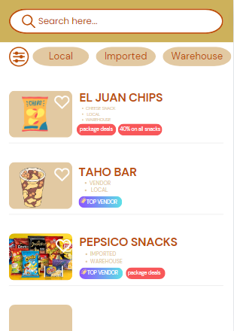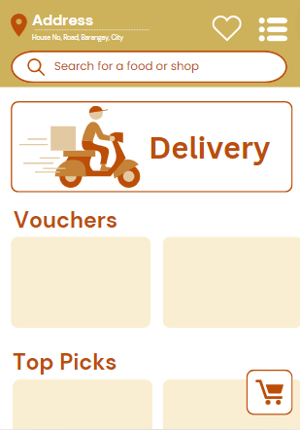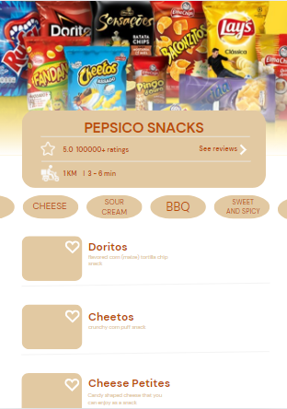

**CHAPTER IV**

**EVALUATION OF PROTOTYPING**

This chapter contains the evaluation of the prototype and the results and feedback of future users.

**Evaluation Plan**

The application’s prototype will be judged on the following questions to gauge the users’ feedback on the aesthetic and the ease of use:

1. How was the overall aesthetics and design of the application?
2. How was the ease of navigating through the app?
3. How was the ease of ordering in the app?
4. Rate the aesthetics of each following component:
   1. Authentication page
   2. Home page
   3. Vendors page
   4. Take-out page

**Results**

Using a small-scale, quick survey made on Google Forms, potential users were asked to rate the application according to the evaluation plan. The results are as follows.

**Q1.** How was the overall aesthetics and design of the application?

|  |  |
| --- | --- |
| **PARTICIPANT** | **SCORE** |
| 1 | 5 |
| 2 | 3 |
| 3 | 4 |
| 4 | 5 |
| 5 | 5 |
| **MEAN** | 4.4 |
| **EVALUATION** | Satisfactory |

**Q2.** How was the ease of navigating through the app?

|  |  |
| --- | --- |
| **PARTICIPANT** | **SCORE** |
| 1 | 5 |
| 2 | 4 |
| 3 | 4 |
| 4 | 5 |
| 5 | 5 |
| **MEAN** | 4.6 |
| **EVALUATION** | Satisfactory |

**Q3.** How was the ease of ordering in the app?

|  |  |
| --- | --- |
| **PARTICIPANT** | **SCORE** |
| 1 | 5 |
| 2 | 4 |
| 3 | 5 |
| 4 | 5 |
| 5 | 5 |
| **MEAN** | 4.8 |
| **EVALUATION** | Satisfactory |

**Q4.** Rate the aesthetics of each following component:

1. Authentication page

|  |  |
| --- | --- |
| **PARTICIPANT** | **SCORE** |
| 1 | 4 |
| 2 | 3 |
| 3 | 3 |
| 4 | 5 |
| 5 | 5 |
| **MEAN** | 4 |
| **EVALUATION** | Satisfactory |

1. Home page

|  |  |
| --- | --- |
| **PARTICIPANT** | **SCORE** |
| 1 | 5 |
| 2 | 4 |
| 3 | 5 |
| 4 | 5 |
| 5 | 5 |
| **MEAN** | 4.8 |
| **EVALUATION** | Satisfactory |

1. Vendors page

|  |  |
| --- | --- |
| **PARTICIPANT** | **SCORE** |
| 1 | 5 |
| 2 | 4 |
| 3 | 5 |
| 4 | 5 |
| 5 | 5 |
| **MEAN** | 4.8 |
| **EVALUATION** | Satisfactory |

1. Take-out page

|  |  |
| --- | --- |
| **PARTICIPANT** | **SCORE** |
| 1 | 5 |
| 2 | 4 |
| 3 | 5 |
| 4 | 5 |
| 5 | 5 |
| **MEAN** | 4.8 |
| **EVALUATION** | Satisfactory |

**Feedback**

**P1*.*** wa tay mahimo bai (gwapo man design) preference ko lng centered ang login page.

**P2.** The login screen is a bit too simple. I think the logo must be in the upper middle of the screen

**P3.** Login screen could be better, and the shade of brown used behind the search bar is too green IMO.

**Discussion**

As seen from the results, the overall aesthetic was rated at a mean of 4.4, which was Satisfactory. The ease of navigation was rated at 4.6, and the ease of ordering was rated at 4.8, which were also both Satisfactory. Moving to the aesthetic rating of each component, the authentication page garnered a mean of 4, which was the lowest mean score, but was still Satisfactory. The other pages such as the home screen, vendors page, and the takeout page were all rated at 4.8, rated Satisfactory.

From the feedback, most of the participants thought that the login screen should be improved, and the colors of the home screen’s search bar changed to match the vibrancy of the other colors.

Overall, the app is rated Satisfactory in all aspects of the evaluation plan.

**CHAPTER V**

**SUMMARY AND CONCLUSION**

**Summary**

To summarize, our project, Snak, is created to cater to the Filipino food-delivery market that seeks to order quick snacks that can be local or imported. The project seeks to address the lack of food-delivery services that do so, and the project also seeks to promote local vendors by making them easily accessible for the Filipino market.

**Conclusion**

In conclusion, through rigorous design process, the app has garnered overall satisfactory ratings from its future users. While there are still areas to improve on such as the login screen and color scheme. If we had more time, we would most definitely look into adding more utility screens such as the cart, the account settings, and improving the color scheme. Despite the lack of these, the application’s prototype has shown great promise.